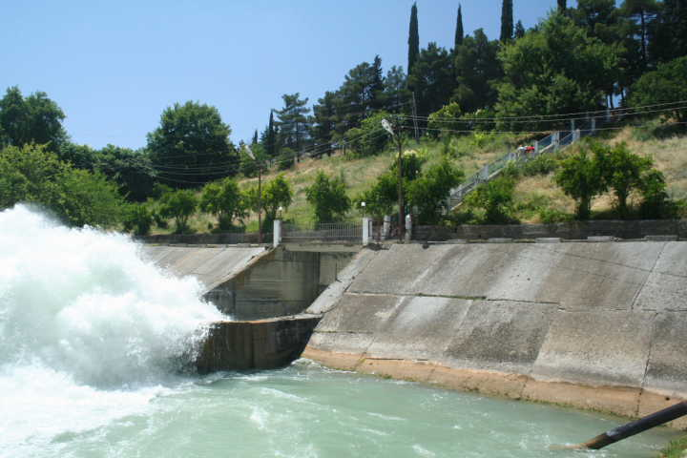
Tackling trade-offs between water and energy across sectors and scales - Outcomes Report
3 hour seminar held on Sunday 1.9.2014 at the Stockholm World Water Week 2014, co convened by Swiss Water Partnership, CSD Engineers; Global Institute for Water, Environment and Health (GIWEH); Group E; International Centre for Water Management Services (cewas); International Development Enterprises (iDE); SoPAS, Water Resource Group 2030 (WRG2030); Swiss Federal Institute of Aquatic Science and Technology (EAWAG, SANDEC department); Skat consulting; Swiss Agency for Development and Cooperation (SDC) and the International Platform for Water Law, University of Geneva (UNIGE).

Context
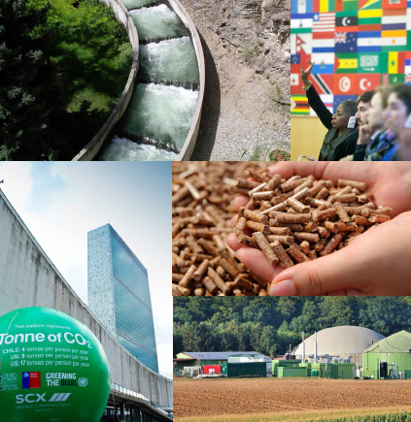
Freshwater and energy are crucial for human well-being and sustainable socio-economic development. Population- and economic growth and changing consumer behaviors will increase the demand for food, energy and water. By 2030, nearly half of the world’s population will be living in areas of high water stress affecting energy and food security, water resources will globally be overused by 40% and by 2035 global energy demand will increase by 50% mainly caused by non-OECD countries and climate change exacerbates this trend. This leads to decreasing quantity and quality of available water resources and to increasing water, food and energy insecurity. Currently most of these challenges are tackled in a silo approach with fragmented sectorial responsibilities, lack of coordination and cross sector communication. There is consequently a need to improve the management of these limited resources and identify synergies and shared benefices to accommodate interdependencies and minimize negative trade-offs.

This seminar organized by the Swiss Water Partnership presents a series of advanced Swiss solutions aiming at tackling trade-offs between water and energy across sectors and scales. Solutions are discussed in the context of Tanzania and the Middle East and up-scaling potentials are identified.
Figure 1: water food energy inter linkages

Promising solutions
Increasing demand can either be dealt with by improving the management (increasing the savings, reducing the demand) or increasing the supplies, whilst negative trade-offs of the interdependencies have to be tackled by creating shared benefits. Throughout the seminar the following promising solutions were presented:

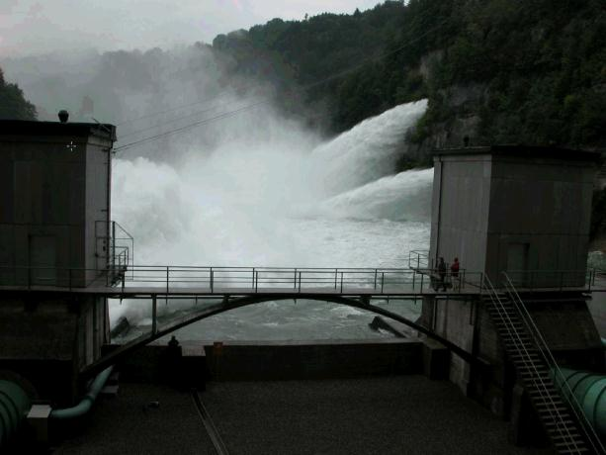
Increase efficiency, managing the demand
CSD Engineers & Groupe E presented integrated wastewater and energy management solutions in Switzerland. Whilst the lake Gruyere power plant built in 1944 only focused on energy production, over time solutions for a series of additional requirements such as drinking water intake, tourism, protection of the ecosystem and flood risk management had to be integrated. Integrated solutions identifying synergies across different interest groups and reducing trade-offs should be aimed at from the very beginning of a new project.
Figure 2: reserve storage for flood protection

iDE & SoPAS presented how more efficient irrigation technologies of smallholder farmers combined with solar energy and market approaches increase the water use efficiency. With the introduction of drip irrigation and the improved efficiency of energy sources smallholder farmers can produce more crop per drop with less energy. For sustainable dissemination a market creation approach with technical assistance and micro-finance is needed.

Increase the resources available, managing the supply
Skat consulting presented a combined solution to use hidden energy potentials in energy in drinking water and irrigation systems in Tunisia and Jordan. Often excessive hydraulic energy in water systems is destroyed, instead of being converted into electricity by upgrading existing infrastructures with micro hydro plants. There is a great potential for scaling-up these upgraded infrastructures, but hurdles such as lack of capacities, funds, no appropriate co-design have to be overcome.
EAWAG & Cewas presented examples how new synergies between sanitation, energy production and agriculture can be created by transforming waste and biomass to energy, fuels, and other useful materials. Examples include innovative composting facilities, biogas sanitation digesters, fecal sludge for animal fodder and slow pyrolysis of waste for char production. Best practices (technical solutions and business models) have to be researched and tested with adequate business models so that a series of context specific solutions are available and can be replicated elsewhere.
Figure 3: Char from waste

Create shared benefits
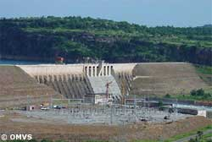
The international water law platform of the Geneva University presented how the joint ownership of infrastructure in a trans-boundary watercourse can foster cooperation of water and energy resources. The legal framework of the Senegal river helped in the planning, implementation and operation of joint water infra-structures such as the Diama and Manantali dams. For up-scaling, financing institutions supporting trans-boundary infrastructure projects play a key role.

Figure 4: Manatali Dam on Senegal river
The Swiss Agency for Development and Cooperation’s presentation confirmed the important role of coherent policies to manage water and energy resources in trans-boundary watercourses and explained how a project to use joint water and energy resources can foster peace and cooperation among neighbouring states. The scaling up of such solutions depends on the political environment of the neighbours and on the legal framework applicable.

Scaling-up potential

Do proposed solutions match reality?
The Water Resources Group 2030 presented the hydro-economic realities in Tanzania and how they try to support a business case for sustainable water resource management. Proposed remedies include improved farming and irrigation practices, future strategic management of water resources and promoting cross sectorial integrated planning for which many of the presented solutions are highly relevant.
The Global Institute for Water, Environment and Health presented the water-food-energy interdependencies in the Near and Middle East (MENA) and illustrated that green economy has great potential to solve some of the great challenges for this region with 57% of world’s oil resources and only 1% of the global freshwater.
Figure 5: Tanzania water availability

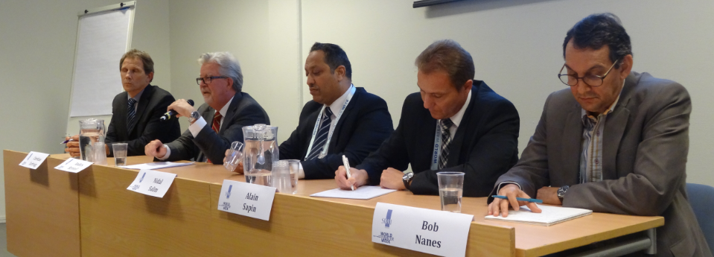
Panel discussion
Panellists (from left to right): Chris Zurbrügg, Anders Berntell, Nidal Salim, Alain Sapin, Bob Nanes

Success factors for promoting integrated approaches and scaling up cross-sector solutions?
- Purely technical solutions are easier to bring at scale than solutions touching upon politically sensitive issues. Solutions across different sectors and countries require trust and time, but have the greatest potential (Anders Berntell).
- Thinking about regional and large scale solutions is important, but in parallel small scale projects with a direct positive impact on the livelihood of the local population should be implemented (Nidal Salim).
- It is very important to act local whilst thinking global and including stakeholders from other sectors to finding integrated solutions from the beginning. (Alain Sapin)
- We have to expand our horizon and start seeing the business opportunities to generate additional value from smart waste management. We need research and test technical solutions, develop sustainable business models and put them into practice in the local context. Scaling up does not necessarily mean making it bigger, but it also means replicating a well-functioning solution. (Chris Zurbrügg)
- Solving problems depends a lot about the local economy and thus level of poverty and food production play an important role. Scaling-up/replicating small scale solutions depends upon (Bob Nanes)
- Product design, business model and value chain;
- Private sector involvement and the supply chain;
- Communication to change the mind-set and behaviour of the people
- To assure that these different projects are integrated in a strategic view it is crucial to doing previous analytical work pointing out different options and economic opportunities whilst involving different actors affected.

Conclusions (Olga Darazs)
- We need to change our mind-sets and think more integrated
- There is no one fits it all solution, a variety of tailor made solutions is needed
- The water, energy and food crisis is an opportunity for new innovative solutions

Next steps
- Closer collaboration among co convenors coming from different sectors and scales
- Swiss conference on water and energy challenges and trade offs
- SWP input paper on water & energy

